# **REQUIREMENTS DOCUMENTATION**

## **INFOSYS EMERGENCY AND MENTAL WELL BEING PROJECT**

**GROUP NUMBER:** GROUP 2

**TEAM LEAD:** MUHAMMAD FIRAS

**TEAM MEMBERS:**

1. BIDYUT
2. SIDHARTHA
3. AMAN CHOWDHARY
4. KIRTI PANDEY

**SUMMARY:**

The "Emergency and Mental Well-Being" application is a full-stack platform designed to provide immediate support and resources for individuals experiencing mental health crises or seeking mental well-being services. It connects users to a network of mental health professionals, offers tools for self-assessment, and provides educational resources to promote mental well-being. The platform enables users to access support, monitor personal progress, and access emergency contact options quickly.

**INDEX**

1. **Scope of the Project**
2. **Functional Requirements**
3. **Non-Functional Requirements**
4. **Tech Stack Used**
5. **User Stories**
6. **Database Design**
7. **Scope of the Project:**
8. **1 User Features:**
   * **Registration and Login:** Secure user registration and authentication.
   * **Self-Assessment Tools:** Access to tools for evaluating mental health status.
   * **Resource Library:** A database of resources such as articles, videos, and exercises.
   * **Emergency Support:** Quick-access features to reach mental health professionals or emergency contacts.
   1. **Professional Features:**
   * **Professional Registration:** A portal for mental health professionals to register and offer their services.
   * **Appointment Management:** Scheduling and managing sessions with users.
   * **Resource Contribution:** Professionals can add resources and tools to the platform.
   1. **System Features:**

**Analytics and Reporting:** Tracks user engagement and common mental health needs.

* 1. **Personalized Suggestions**: Recommends resources based on user activity and assessments.

1. **Functional Requirements:**

**2.1 User Functional Requirements:**

* **Registration and Login:** Users can create an account, log in, and manage profiles securely.
* **Self-Assessment Tools:** Users can access questionnaires and tools for mental health self-assessment.
* **Resource Access:** Users can search and browse mental health resources.
* **Emergency Contact Options:** Quick links to emergency contacts or nearby support centers.
* **Progress Tracking:** Users can monitor their mental well-being journey and track improvements**.**

**2.2 Professional Functional Requirements**

* **Registration**: Mental health professionals can register and provide qualifications.
* **Session Management:** Manage appointment requests, session notes, and follow-up reminders.
* **Resource Contribution:** Add resources for the community, such as articles, exercises, and videos.

1. **Non-Functional Requirements**

• **Performance**: Ensure smooth performance during high-traffic periods, especially in emergency situations.

• **Scalability**: The platform should be scalable to accommodate a growing number of users and professionals.

• **Security**: Strong encryption for user data, HIPAA compliance, and secure access control for mental health professionals.

• **Reliability**: High availability with minimal downtime, especially during emergencies.

• **Usability**: A user-friendly interface that makes navigation easy, particularly for users in distress.

• **Maintainability**: The platform should be modular, allowing for regular updates and maintenance.

1. **Tech Stack Used:**

**Frontend:**

**React JS**: To provide a dynamic and responsive interface for users and professionals.

**Backend:**

**Spring Boot**: For scalable and efficient backend services, handling user requests and data processing.

**Database:**

**MongoDB/MySQL**: For storing user data, resources, and

session information securely.

**Microservices:**

**User Management**: Manages user registration, authentication, and profile management.

**Professional Management**: Handles professional registrations and service offerings.

**Resource Management**: Manages mental health resources available on the platform.

**Emergency Support**: Microservice dedicated to emergency features and real-time support connections.

**User Stories**

**1. User Registration and Login**

* Title: User Registration and Login
* As a: User
* I want to: Register for an account and log in to the application
* So that I can: Access personalized features and manage my profile
* Acceptance Criteria:
  + Users can register with an email address and password.
  + Users receive a confirmation email upon successful registration.
  + Users can log in with their registered email and password.
  + Users can reset their password if forgotten.

**2. Emergency Contact Access**

* Title: Emergency Contact Access
* As a: User
* I want to: Access emergency contact options quickly
* So that I can: Reach out for help in urgent situations
* Acceptance Criteria:
  + Emergency contact details are prominently displayed on the home page.
  + Users can click to call an emergency helpline or a preset contact.

**3. Mental Health Resource Browsing and Search**

* Title: Mental Health Resource Browsing and Search
* As a: User
* I want to: Browse and search for mental health resources (articles, videos, helplines)
* So that I can: Find information and support that meets my needs
* Acceptance Criteria:
  + Users can view a list of resources with titles, descriptions, and access links.
  + Users can filter resources by category (e.g., anxiety, stress, depression).
  + Users can search resources by keyword or title.

**4. Self-Assessment for Mental Well-Being**

* Title: Self-Assessment for Mental Well-Being
* As a: User
* I want to: Complete a self-assessment questionnaire
* So that I can: Gain insight into my current mental well-being
* Acceptance Criteria:
  + Users can complete a self-assessment questionnaire.
  + Responses are saved securely for tracking purposes.
  + Users receive personalized feedback and recommendations based on their responses.

**5. Appointment Booking with Mental Health Professionals**

* Title: Appointment Booking with Mental Health Professionals
* As a: User
* I want to: Book a session with a mental health professional
* So that I can: Receive one-on-one guidance and support
* Acceptance Criteria:
  + Users can view available times for mental health professionals.
  + Users can schedule an appointment from the available times.
  + Users receive confirmation and reminders for their appointments.

**6. Personal Dashboard for Tracking Activity**

* Title: Personal Dashboard for Tracking Activity
* As a: User
* I want to: View my activity history and past appointments
* So that I can: Monitor my mental health journey over time
* Acceptance Criteria:
  + Users can view a list of past appointments, self-assessment results, and accessed resources.
  + Users can track changes over time with a summary or chart of their mental health progress.

**7. Bookmarking and Saving Resources**

* Title: Bookmarking and Saving Resources
* As a: User
* I want to: Bookmark specific resources
* So that I can: Easily access them later
* Acceptance Criteria:
  + Users can bookmark resources, which are saved in a "Bookmarked" section.
  + Users can access all saved resources from their dashboard.

**Professional Stories**

**1. Professional Registration and Profile Creation**

* Title: Professional Registration and Profile Creation
* As a: Mental Health Professional
* I want to: Register my profile and display my qualifications
* So that I can: Be recognized as a verified professional on the platform
* Acceptance Criteria:
  + Professionals can register with details like name, qualifications, and contact info.
  + Professionals receive confirmation upon successful registration.

**2. Session Availability Management**

* Title: Session Availability Management
* As a: Mental Health Professional
* I want to: Set my session availability
* So that I can: Allow users to book sessions based on my schedule
* Acceptance Criteria:
  + Professionals can manage their availability on a calendar.
  + Professionals can modify or update their schedule.

**3. Dashboard for User Engagement and Performance Analytics**

* Title: Dashboard for User Engagement and Performance Analytics
* As a: Admin
* I want to: View analytics on user engagement and resource usage
* So that I can: Improve the platform’s offerings
* Acceptance Criteria:
  + Admins can access aggregated data on resource engagement, appointment bookings, and self-assessment completions.
  + Admins can monitor metrics like most-viewed resources and average assessment scores.

1. **Database Design:**

**Database Tables**

**1. Users Table**

* **Purpose**: Stores information about registered users, including login credentials and profile details.
* **Columns**:
  + user_id (PK, INT, AUTO_INCREMENT): Unique identifier for each user.
  + email (VARCHAR, UNIQUE): User’s email for login.
  + password_hash (VARCHAR): Hashed password for secure login.
  + name (VARCHAR): User’s name.
  + role (ENUM): Role of the user (e.g., "user" or "professional").
  + created_at (DATETIME): Timestamp of account creation.
  + updated_at (DATETIME): Timestamp of the last profile update.

**2. Professionals Table**

* **Purpose**: Stores details specific to mental health professionals.
* **Columns**:
  + professional_id (PK, INT, AUTO_INCREMENT): Unique identifier for each professional.
  + user_id (FK, INT): Foreign key linking to the Users table.
  + qualification (VARCHAR): Professional's qualifications.
  + bio (TEXT): Short biography or description of expertise.
  + profile_picture (VARCHAR): URL or path to profile picture.
  + availability_schedule (TEXT): Schedule or availability in JSON format or other suitable structure.
  + created_at (DATETIME): Timestamp of profile creation.

**3. Resources Table**

* **Purpose**: Stores mental health resources, such as articles, videos, and links.
* **Columns**:
  + resource_id (PK, INT, AUTO_INCREMENT): Unique identifier for each resource.
  + title (VARCHAR): Title of the resource.
  + description (TEXT): Brief description of the resource.
  + type (ENUM): Type of resource (e.g., "article", "video", "helpline").
  + url (VARCHAR): Link to the resource.
  + category (VARCHAR): Category of the resource (e.g., "anxiety", "stress").
  + created_at (DATETIME): Timestamp of when the resource was added.

**4. EmergencyContacts Table**

* **Purpose**: Stores emergency contact options for quick access.
* **Columns**:
  + contact_id (PK, INT, AUTO_INCREMENT): Unique identifier for each contact.
  + title (VARCHAR): Name or title of the contact.
  + phone (VARCHAR): Phone number for the contact.
  + description (TEXT): Description or type of emergency help provided.

**5. SelfAssessments Table**

* **Purpose**: Stores self-assessment questionnaires and results for users.
* **Columns**:
  + assessment_id (PK, INT, AUTO_INCREMENT): Unique identifier for each self-assessment.
  + user_id (FK, INT): Foreign key linking to the Users table.
  + responses (JSON or TEXT): Stores responses in JSON format for easy parsing.
  + score (INT): Assessment score based on user responses.
  + recommendations (TEXT): Recommendations based on assessment score.
  + created_at (DATETIME): Timestamp of assessment completion.

**6. Appointments Table**

* **Purpose**: Manages appointment scheduling between users and professionals.
* **Columns**:
  + appointment_id (PK, INT, AUTO_INCREMENT): Unique identifier for each appointment.
  + user_id (FK, INT): Foreign key linking to the Users table.
  + professional_id (FK, INT): Foreign key linking to the Professionals table.
  + scheduled_time (DATETIME): Scheduled time of the appointment.
  + status (ENUM): Status of the appointment (e.g., "scheduled", "completed", "cancelled").
  + created_at (DATETIME): Timestamp of when the appointment was booked.

**7. UserBookmarks Table**

* **Purpose**: Stores user bookmarks for quick access to favorite resources.
* **Columns**:
  + bookmark_id (PK, INT, AUTO_INCREMENT): Unique identifier for each bookmark.
  + user_id (FK, INT): Foreign key linking to the Users table.
  + resource_id (FK, INT): Foreign key linking to the Resources table.
  + created_at (DATETIME): Timestamp of when the resource was bookmarked.

**8. UserProgress Table**

* **Purpose**: Tracks user’s progress in terms of assessments, appointments, and resource usage.
* **Columns**:
  + progress_id (PK, INT, AUTO_INCREMENT): Unique identifier for each progress entry.
  + user_id (FK, INT): Foreign key linking to the Users table.
  + type (ENUM): Type of progress tracked (e.g., "assessment", "appointment", "resource").
  + reference_id (INT): Links to the relevant ID in the corresponding table (e.g., assessment_id, appointment_id, or resource_id).
  + date (DATETIME): Date of the progress record.

**9. AdminAnalytics Table**

* **Purpose**: Stores aggregated analytics data for platform usage, helping admins monitor engagement.
* **Columns**:
  + analytics_id (PK, INT, AUTO_INCREMENT): Unique identifier for each analytics entry.
  + metric (VARCHAR): Type of metric (e.g., "user_logins", "resource_views").
  + value (INT): Value or count for the metric.
  + date (DATE): Date for daily, weekly, or monthly tracking.

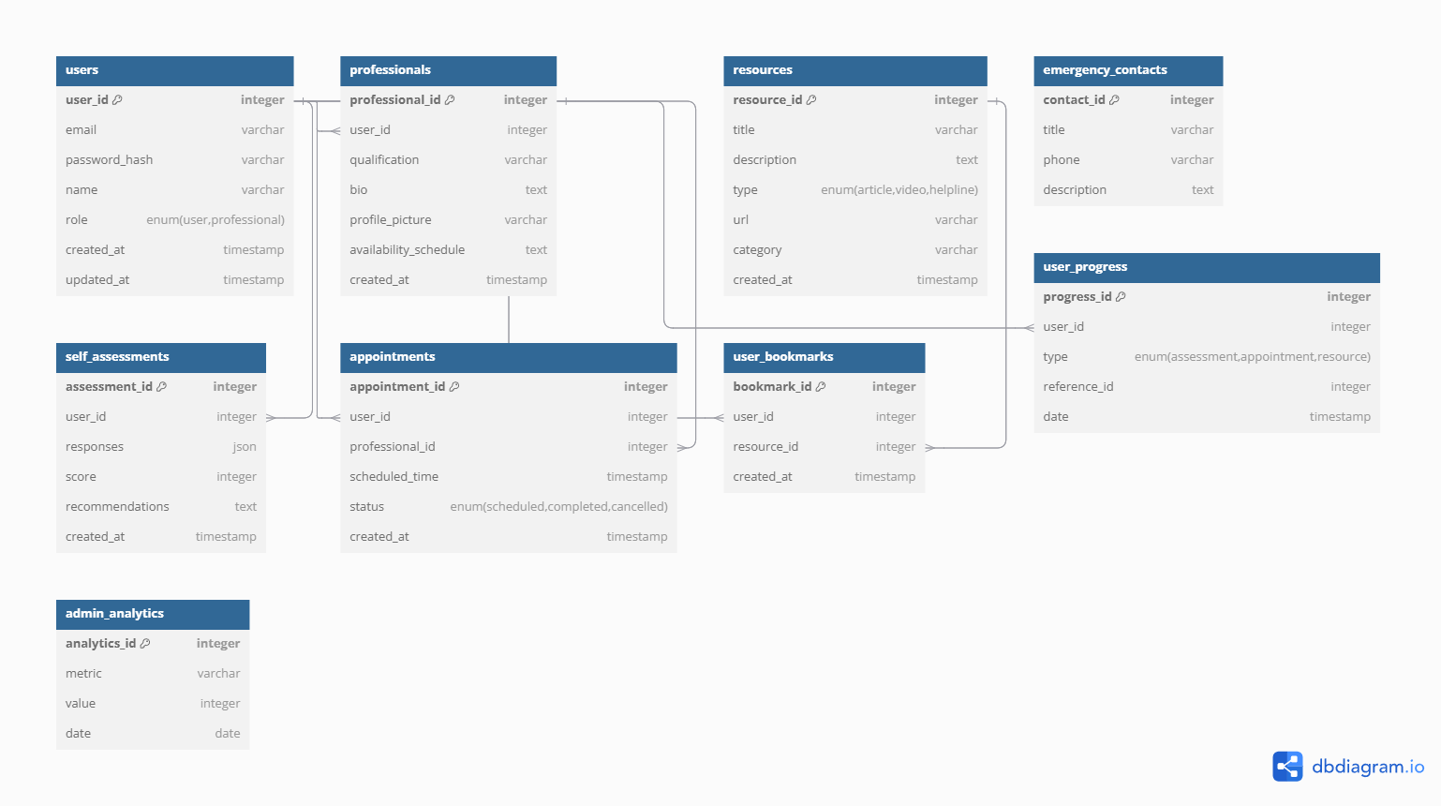

**Relationships**

* **Users** can be linked to **SelfAssessments**, **Appointments**, **UserBookmarks**, and **UserProgress** for tracking individual engagement.
* **Professionals** are linked to **Users** through **Appointments**, where a professional may have multiple appointments with different users.
* **Resources** can be accessed by **Users** directly or bookmarked for easy access.
* **EmergencyContacts** provide essential information accessible to all users but may not have direct relational dependencies.